INFORMATION TO COMPETITORS FROM THE JURY

This document does not in any way modify or replace the rules of the competition.

Protests by the Jury on the Water
The jury will not usually protest for a breach of a rule of Part 2 unless they observe an apparent breach of good sportsmanship (RRS 2). Examples of breaches, where the jury will consider protesting, include:

  - Deliberately or knowingly breaking a rule without justification for exoneration and not taking the appropriate penalty;
  - Intimidating other boats, often evidenced by unnecessary shouting or foul language;
  - Team tactics, sailing to benefit another boat to the detriment of your own position;
  - Reckless sailing that results in, or is likely to result in, damage or injury.

Outside Help
RRS 41 applies from a boat’s preparatory signal (see RRS 41 and the definition Racing). A boat shall not receive instructions or exchange sailing gear with a coach or support boat after the preparatory signal.

Propulsion
The ISAF RRS 42 Interpretations 2013-2016 are posted on:

http://www.sailing.org/raceofficials/rule42/index.php

In addition to the ISAF Rule 42 Interpretations, the following points may help you to understand the application of RRS 42:

- Although there are usually two judges in each jury boat, a single judge will signal a yellow flag penalty when satisfied that a boat has broken RRS 42.
- When a boat is penalised for a breach of RRS 42 in a race that is subsequently postponed, recalled or abandoned, the boat may compete in the restarted race. However, every penalty counts in the boat’s penalty total.
- Although judges will signal a RRS 42 penalty as soon as possible, this might be after the boat has crossed the finishing line. In the case of a boat’s first penalty, she must complete the penalty, return to the course side of the finishing line and then finish.
- A boat may only be granted redress when a judge’s action failed to account for a race committee signal or a class rule (see RRS P4)

A competitor may ask the judges for an explanation of a penalty after the completion of the race. It can be done either on or off the water or by asking at the Jury Office to arrange a meeting with the judges.

Requests for Redress, Claiming RC Error in Scoring a Boat OCS or BFD
Boats sometimes want to challenge the race committee’s decision to score them OCS or BFD by requesting redress under RRS 62.1(a).

For a boat to be given redress, the competitor must provide conclusive evidence that the race committee has made an error in identifying the boat as OCS. Even video evidence is rarely conclusive. In the absence of conclusive evidence to the contrary, the jury will uphold the race committee’s decision.

Evidence of the relative positions of two boats that are scored differently is not conclusive evidence that either boat started properly.

Video and Tracking Evidence
A party wishing to bring video or tracking evidence to a hearing is responsible for providing the equipment required to view the evidence. Internet connection will not be generally available during a hearing. It should be possible for all parties and the panel to view the evidence at the same time. Tracking system information, if available, may be presented, but is of limited accuracy. The images produced are enhanced from the actual data as an aid to the viewer. The system may be used to get an indicative position of the boats for visualization, but it is not sufficiently precise to be used for race management purposes or jury decisions that require exact positioning information.
The International Jury is required by RRS 63.6 to take all evidence presented by the parties to a hearing and other evidence it considers necessary. This may include any video recordings.

Requests for Redress or Requests for Reopening between stages
It is the intention of the International Jury to hear requests for redress or requests for reopening as soon as possible, especially between stages of the event. Competitors involved it such requests should be prepared to proceed on schedule.

Observers at Hearings
Each party may bring one person to observe at a hearing, unless the jury panel decides in a particular case that it is inappropriate. Observers must sign and comply with the requirements in the document titled Information for Observers.

RRS 69
Any form of cheating, including not telling the truth in a hearing is a breach of sportsmanship and may result in a hearing under RRS 69 and a very heavy penalty.

Questions on Jury Procedure and Policy
Competitors, team leaders and coaches are welcome to discuss procedure and policy with the jury chairman. He will usually be available by the jury rooms during protest time or can be contacted through the Jury Office.

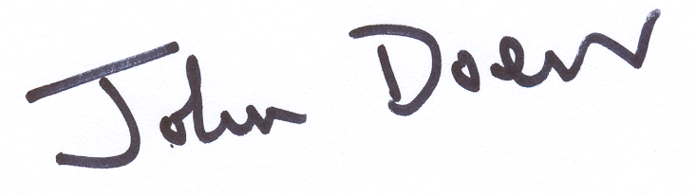

John Doerr, International Jury Chairman

Finn European Championship 2014
May, 2014

